Step 1 - Create a Document Interface

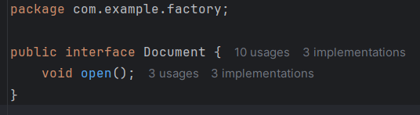

Step 2 - Create an abstract class DocumentFactory

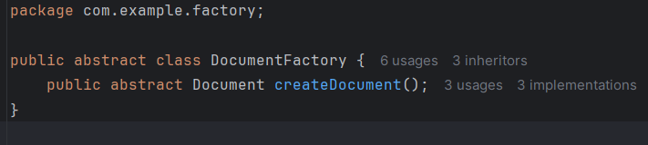

Step 3 - Create the factory classes for word,pdf,excel file (factory and subclass)

For Excel –

Factory Class -

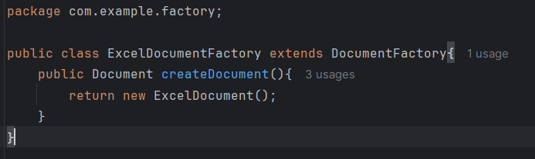

Excel Class –

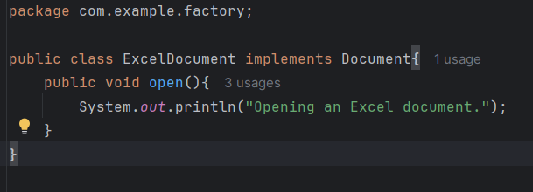

For Pdf –

Factory Class –

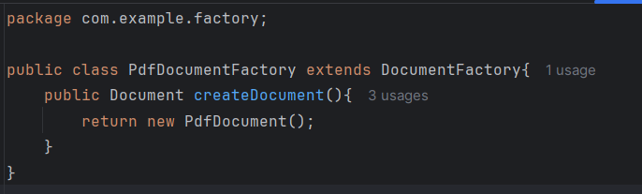

Pdf Class –

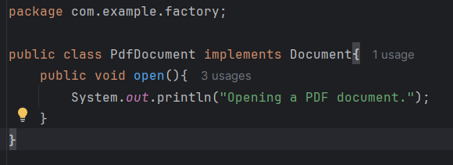

For Word –

Factory Class –

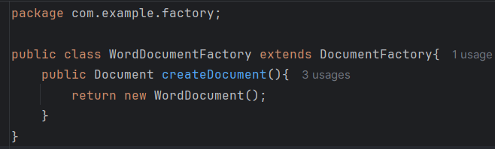

Word Class –

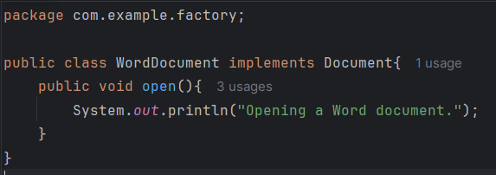

Step 4 – Calling the DocumentFactoryTest main() function –

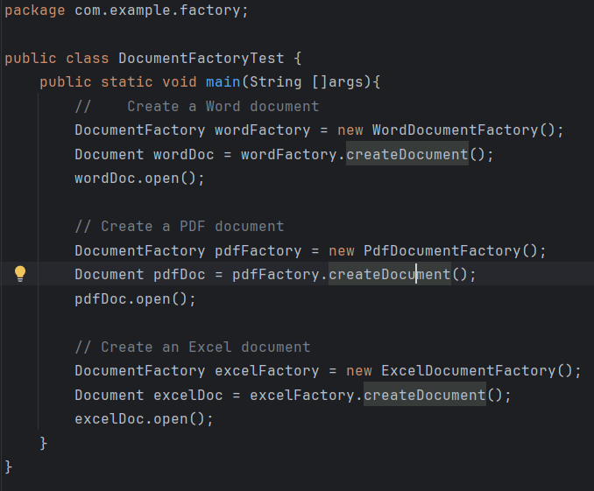

Output –

